LaNier, Robert

CSC-314 Lab0x07 HackMe

Monday April 30, 2018

When I first looked at lab0x07-HackMe the format was different than I was used to. The first thing I did was change the format to something that looked familiar. I added some notes and just ran some simple test adding anything at first and later being more strategic with my input. After I looked at kdbg and got a grasp over what I thought was happening I altered the source code by commenting our a few lines of code in the _modulate function until my buffer overflow gave me access to the NULL Void. This allowed me to understand exactly what was happening which also frustrated me as well since whenever I added the password in and overflowed the buffer the _modulate function would still change some of the characters I entered in. It took me a little while to understand that I just needed to enter the key in a certain area where the code would grab it and compare it with what else I entered which would match.

Running the program using userid 99 to get a feel of how the program works

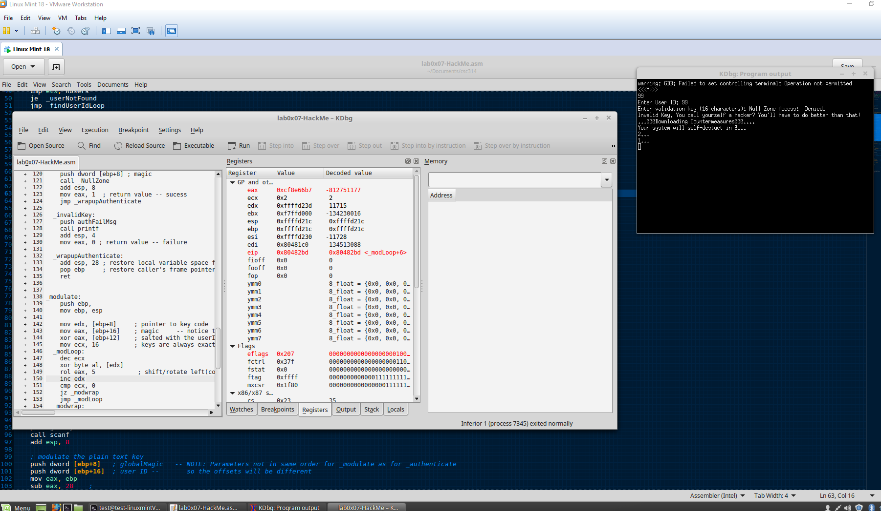

Entering in random numbers to get an understanding of what happens when I enter in a certain length of characters. I learned that if you enter in 32 characters it would seem to loop around and ask you again to enter a validation key.

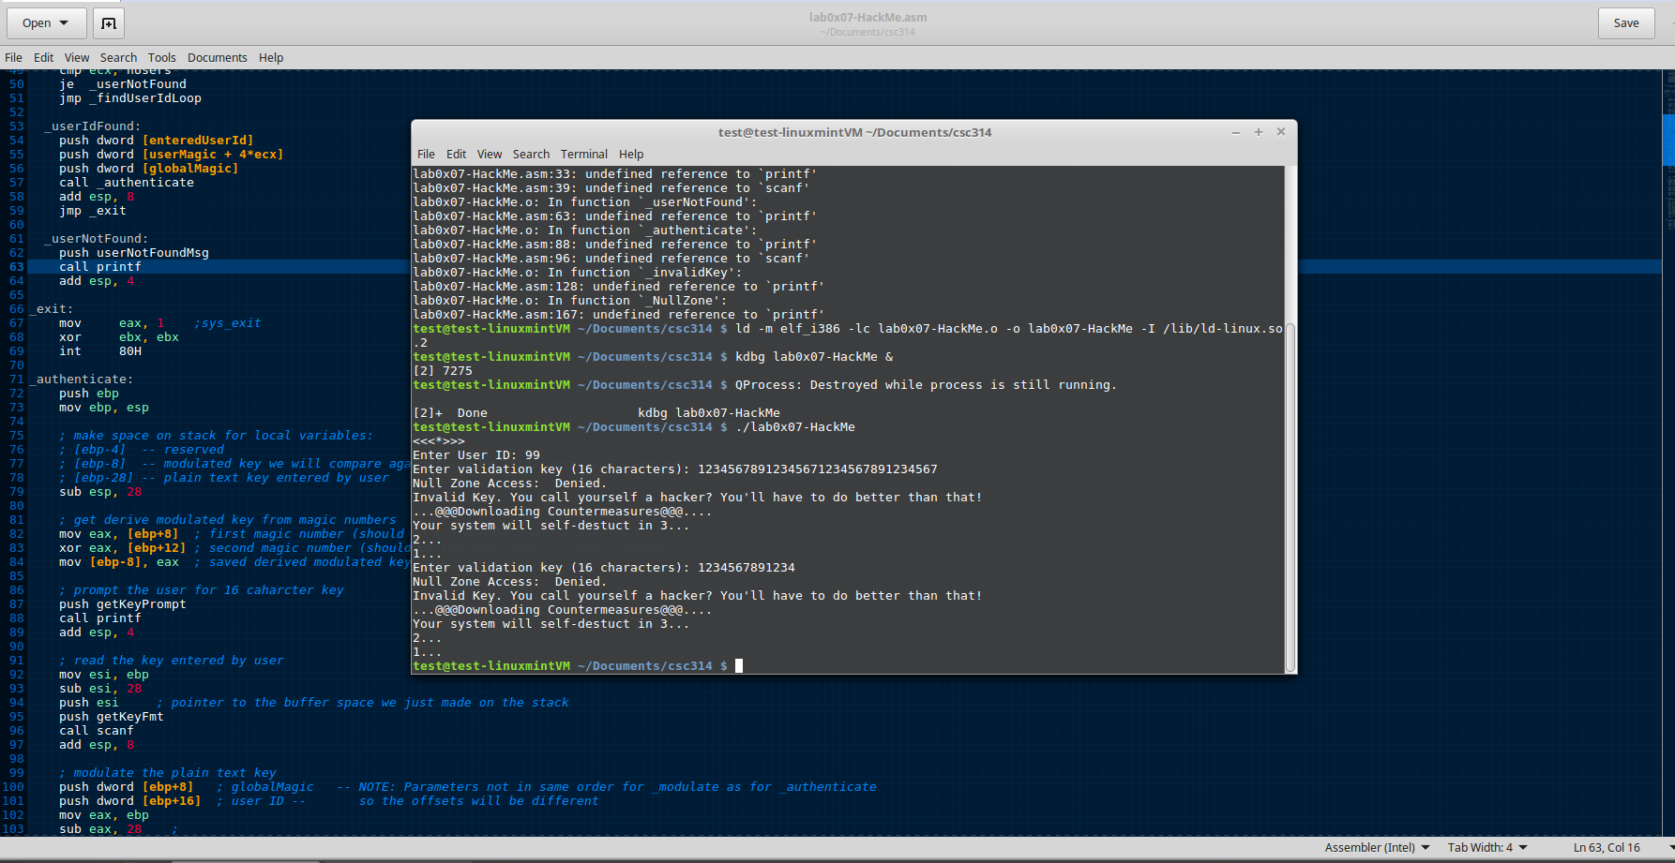

Watching in kdbg what was taking place when I entered in the numbers. I tried to look at the stack in decimal to see if I could get a better understanding of what was happening.

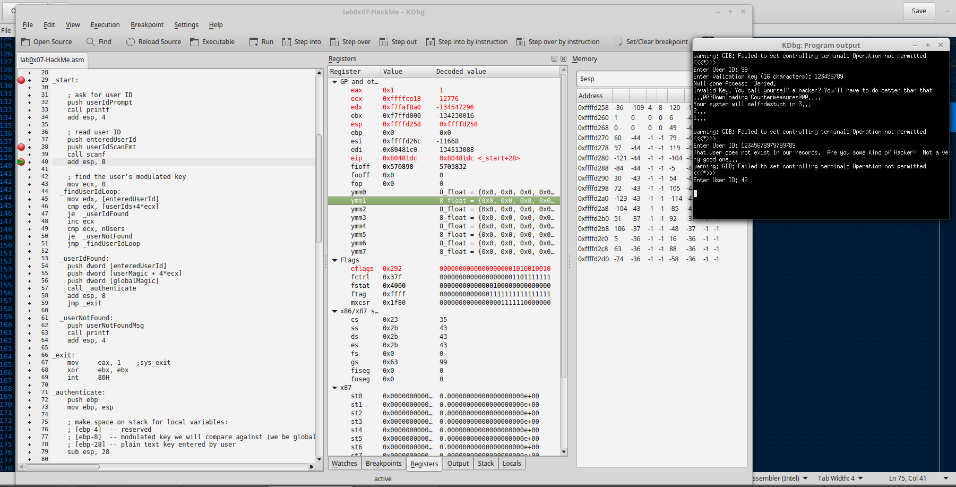

Decided to change my strategy and just concentrate on userid 42 and only enter in the same character for the validation key.

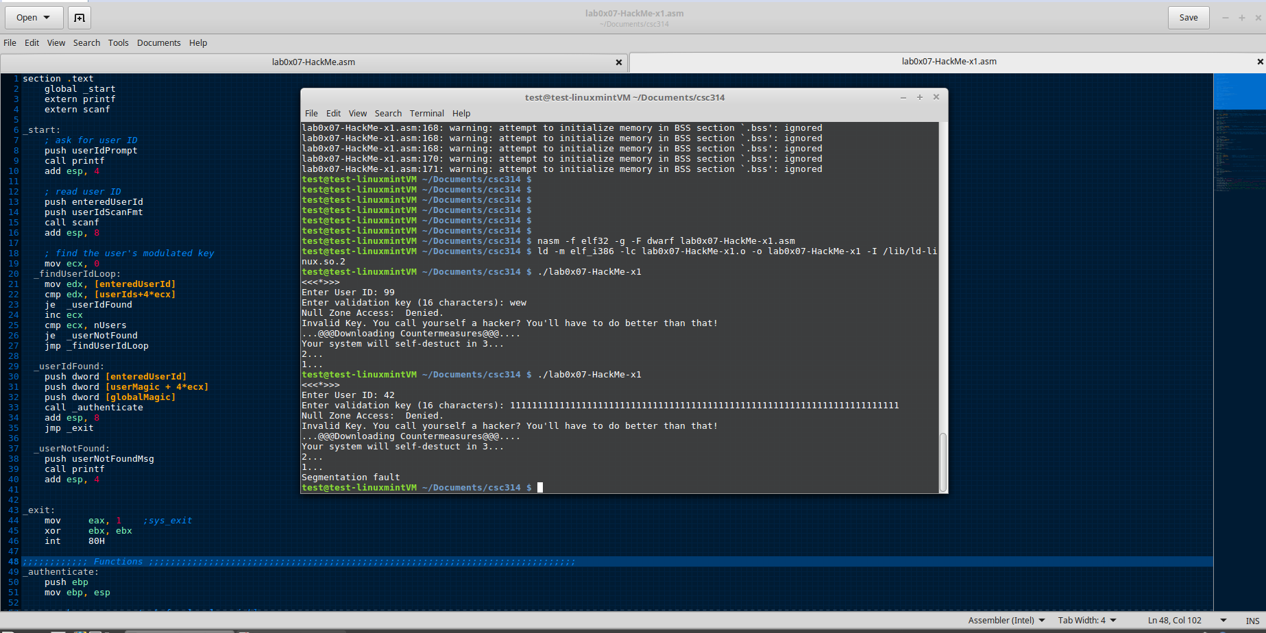

Testing how if you enter a certain number of characters it would loop the program to ask for the validation key again.

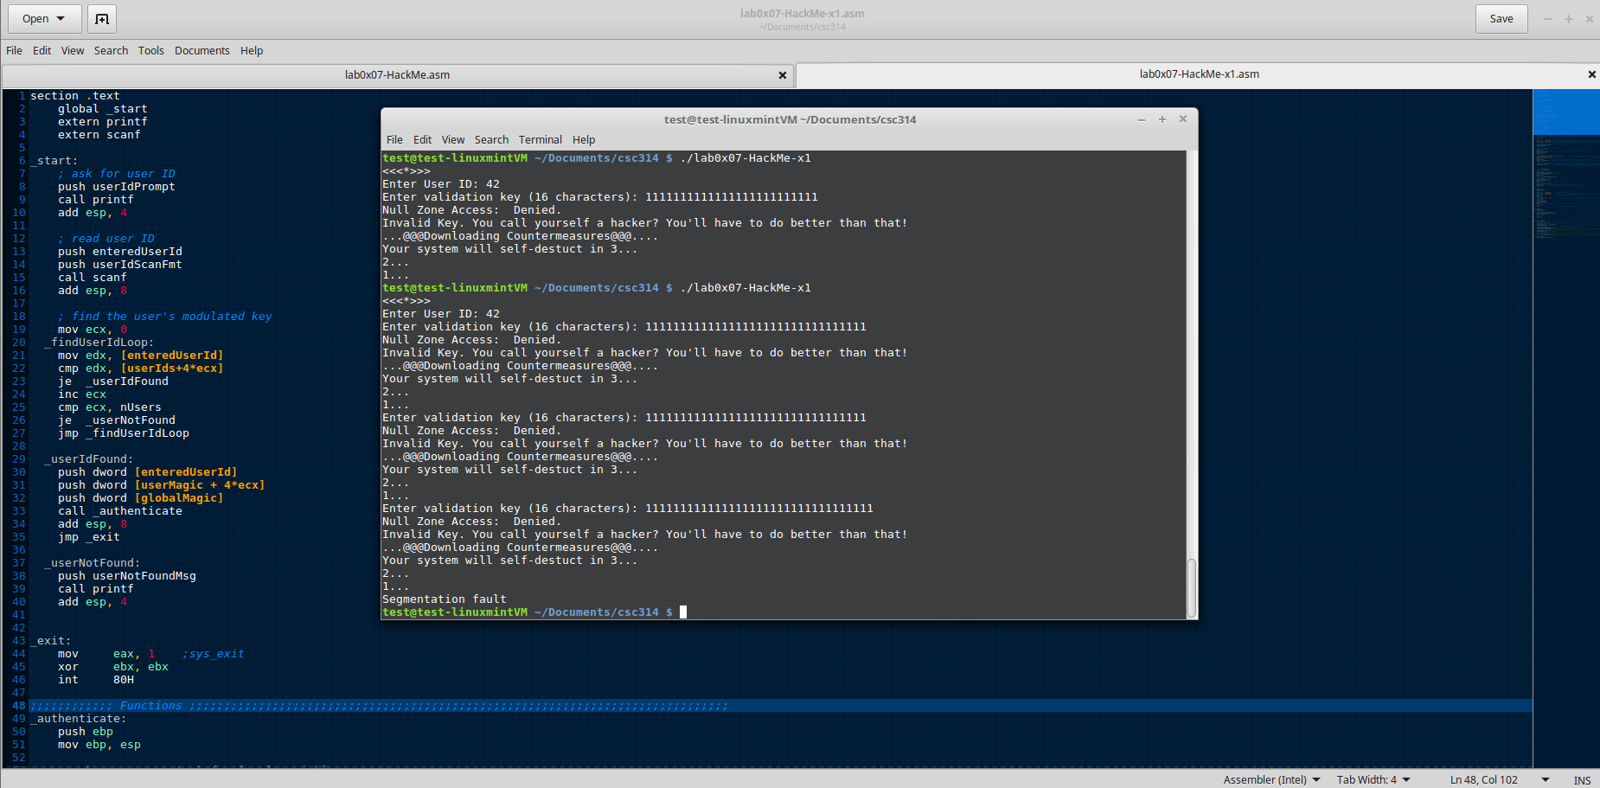

In test x2 I wanted to comment out some of the code to see if I could get into the NULL zone with just a simple buffer overflow.

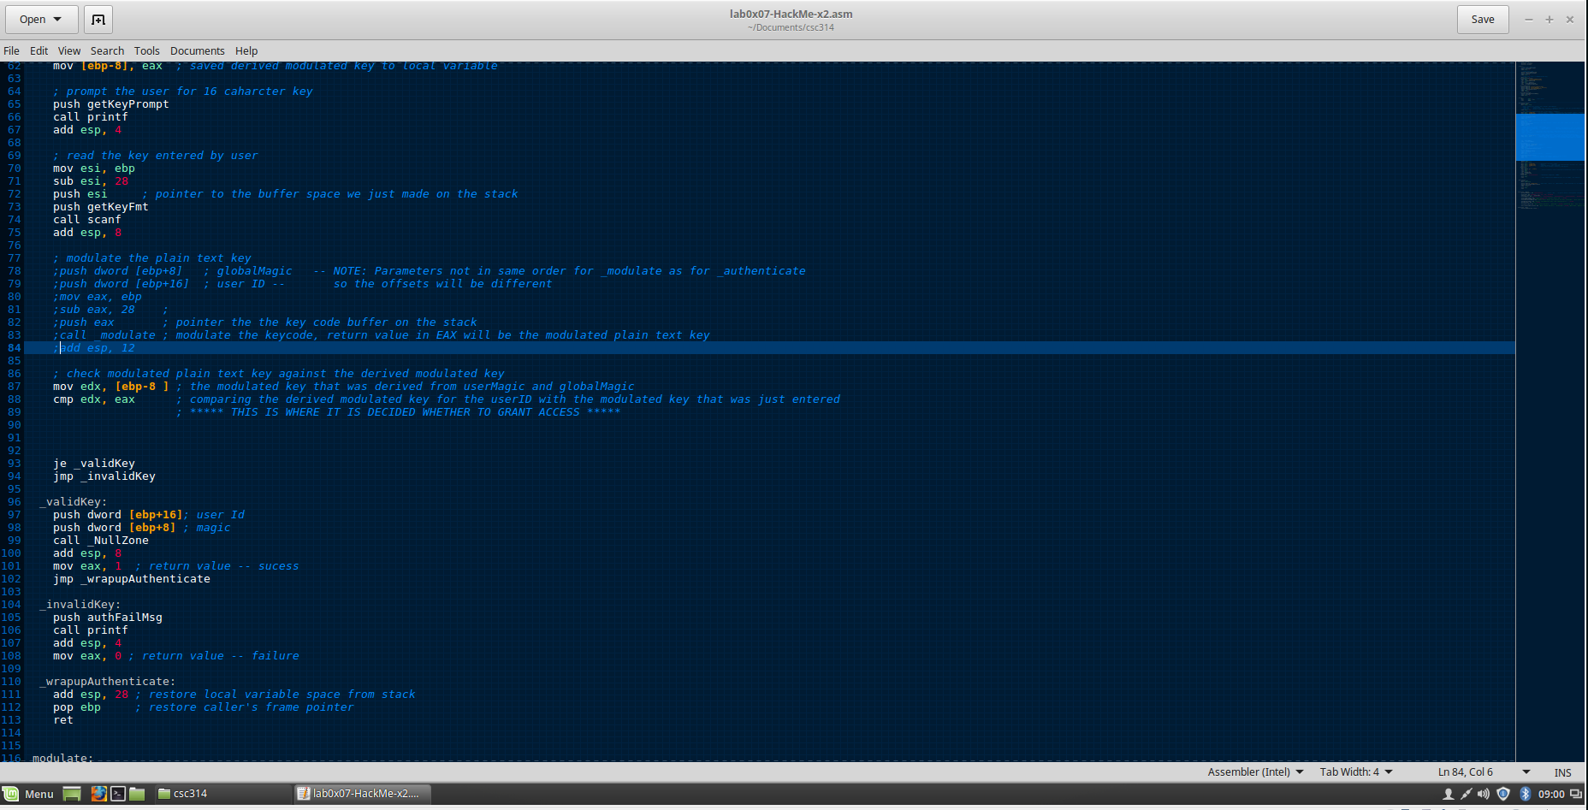

Still working with userid 42, but now trying 0s to test with. Trying different lengths to see what happens.

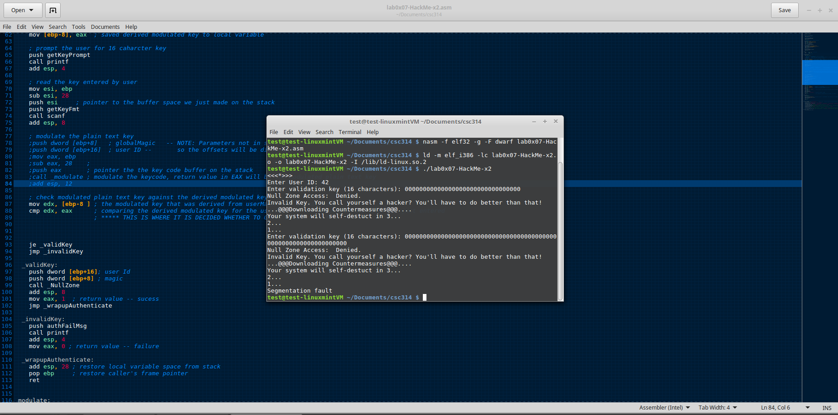

Using kdbg with userid 42 and using 0s for the validation key. Watching what happens with the modified source code x2.

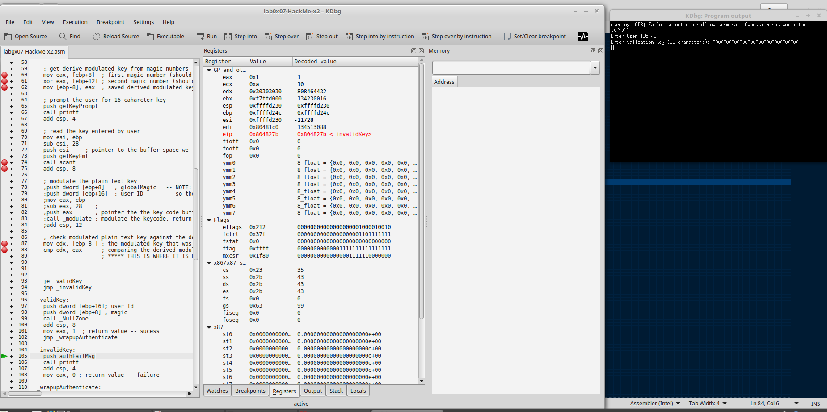

This screenshot shows what was commented out in x2 and me building the program.

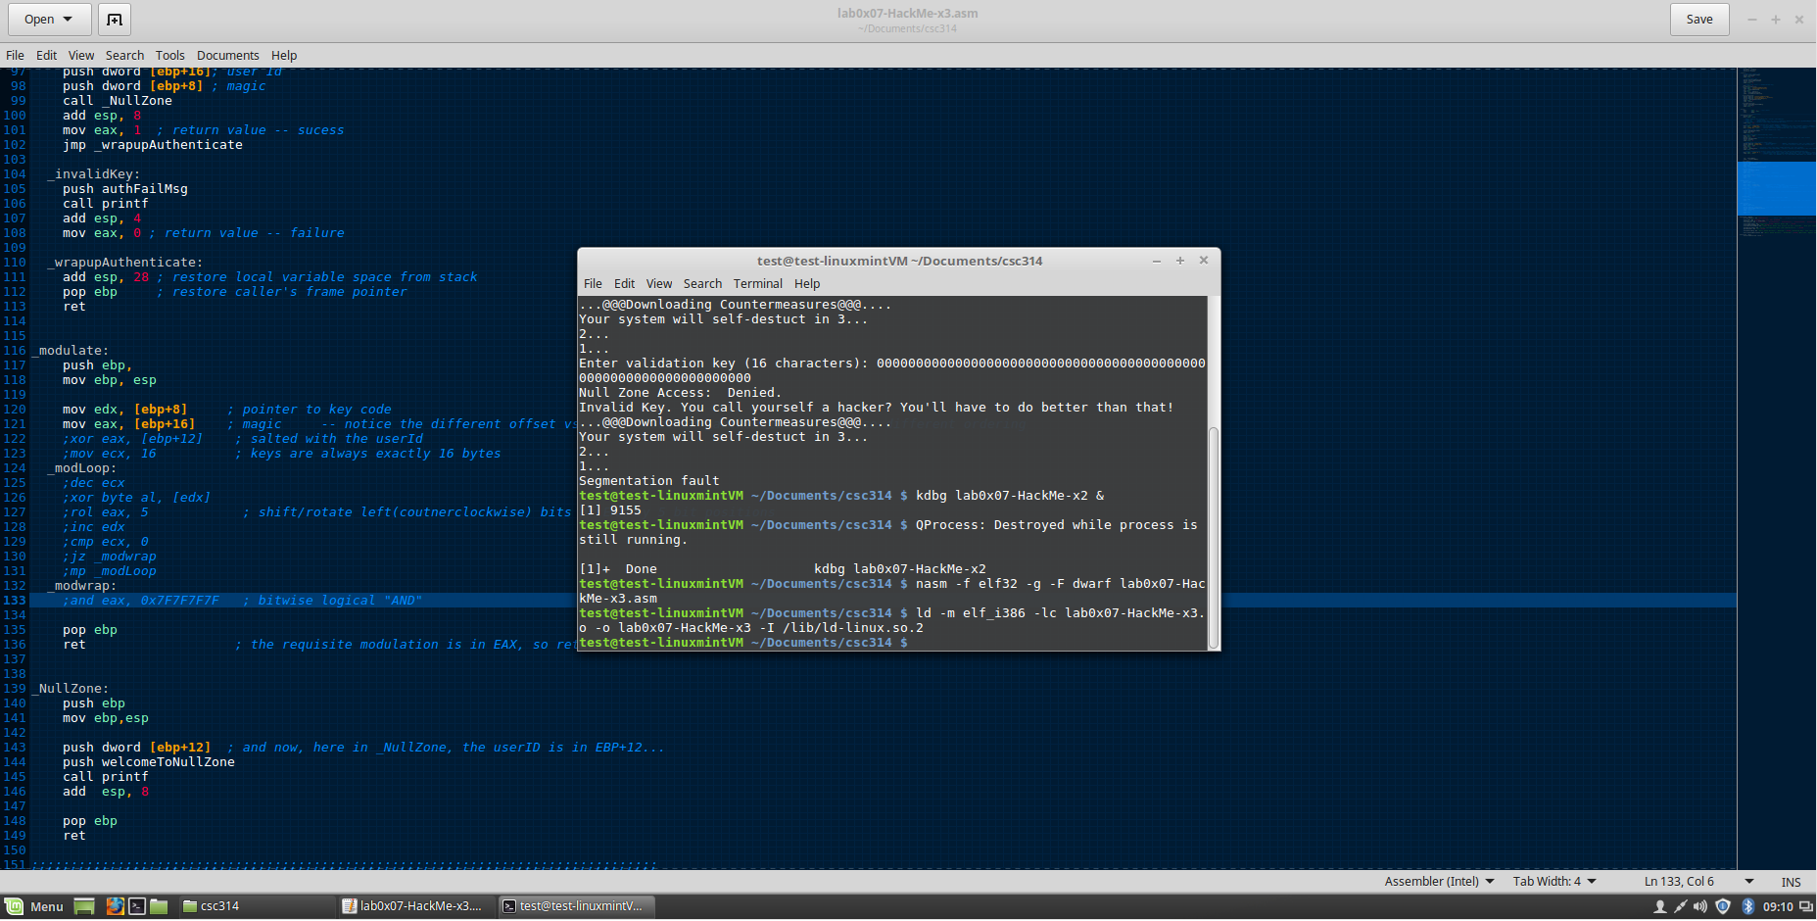

In version x2 I noticed that I had too much commented out so I change the code in version x3 which left some items uncommented. I’m testing it now in kdbg. My goal here is to just overflow the buffer and get into the NULL zone with some lines commented out.

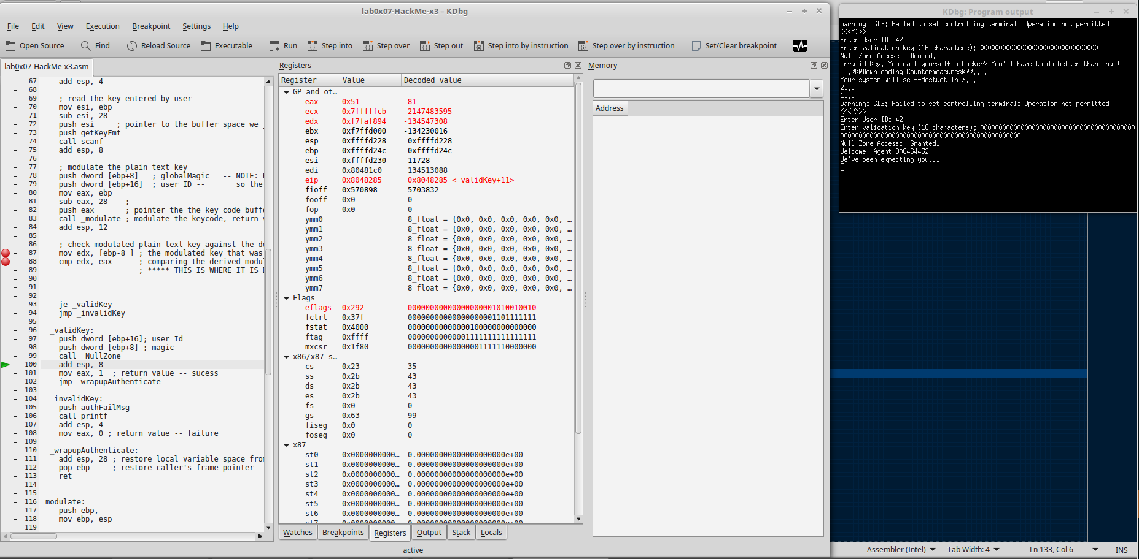

More testing in version x3. Now I’m looking more at the memory

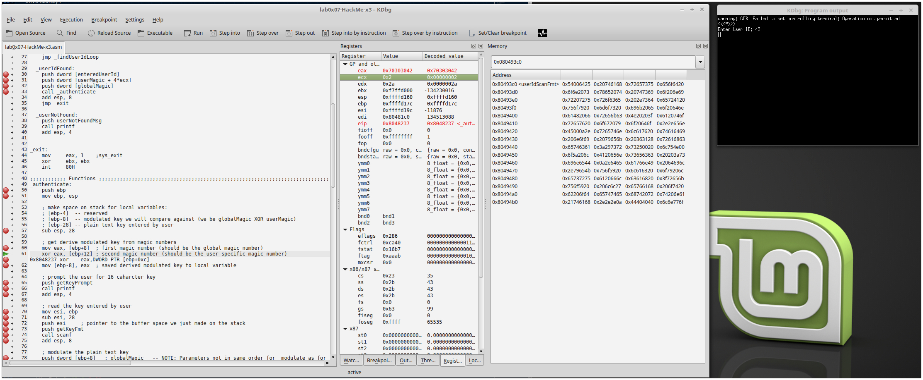

I’m very excited to see all my zeros in the stack!

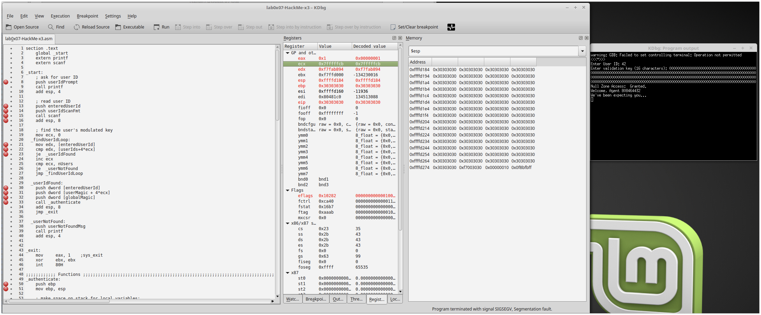

Back testing the original file to see if I see something different than before in version x3

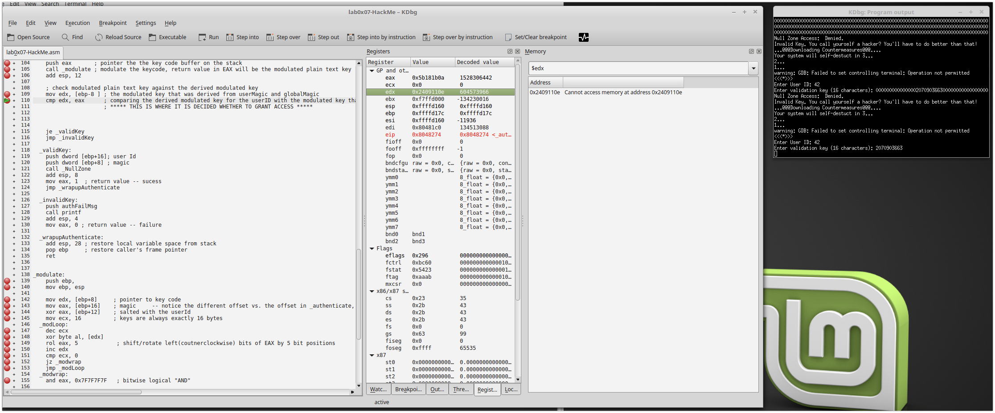

Again I’m very excited that I overflowed the stack with 0s. Just learning how this program works and how I can use that to my advantage.

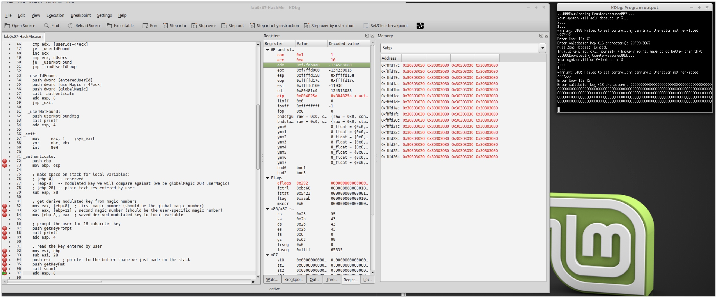

I’ve moved on to version x4 and I’m trying some different stuff besides 0s. I realized that I can overflow the buffer and now I’m trying to see if I can use the signed decimal value to get into the NULL zone. At the time I was just excited to know what the key was and wasn’t thinking about the ascii code which was what was getting entered into the stack.

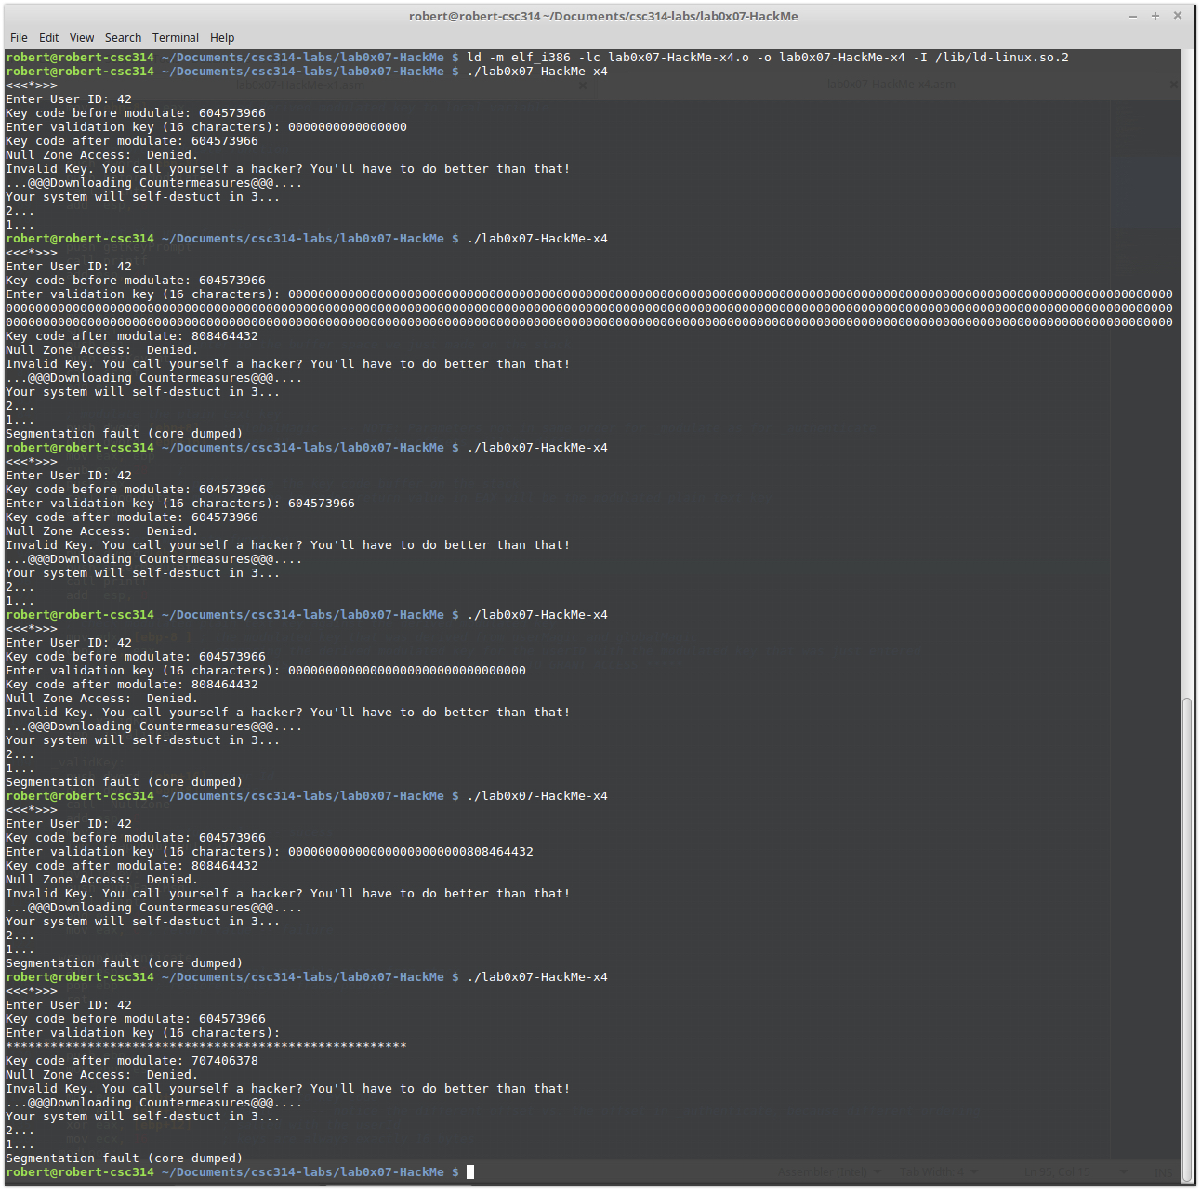

In this screenshot, I think I have the right validation key and I’m testing it

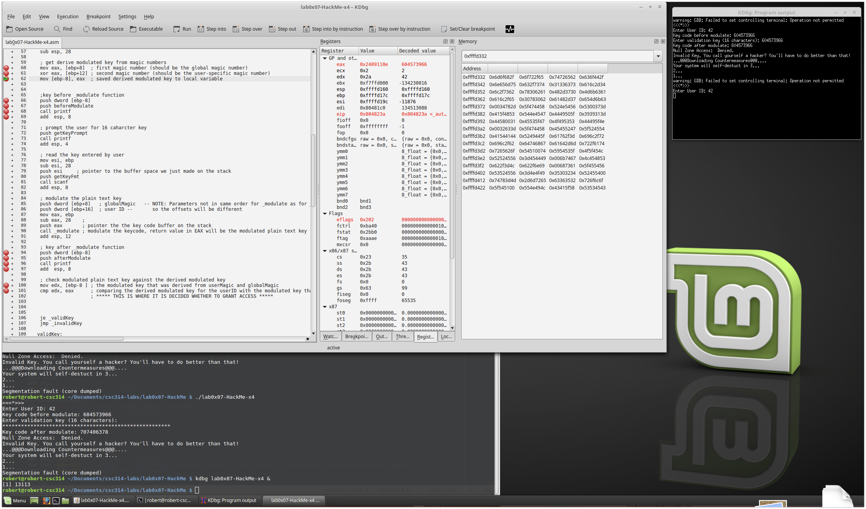

I’ve realized that I need to enter in hexadecimal characters, but I’m just testing out anything at the moment.

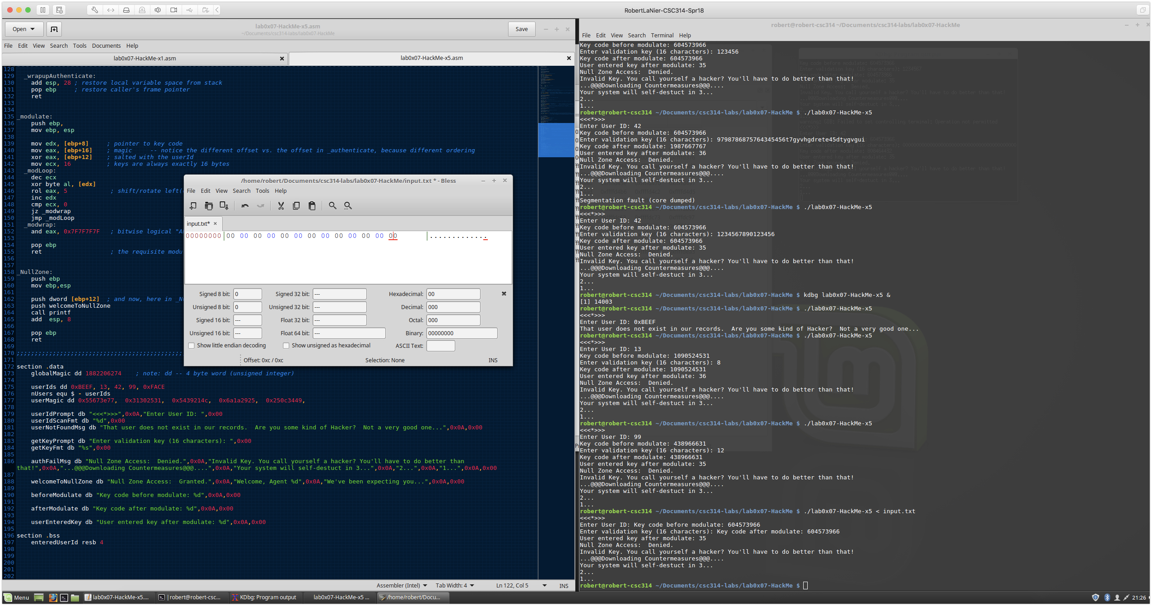

Oh how I love those 0s. Just testing with hexadecimal characters.

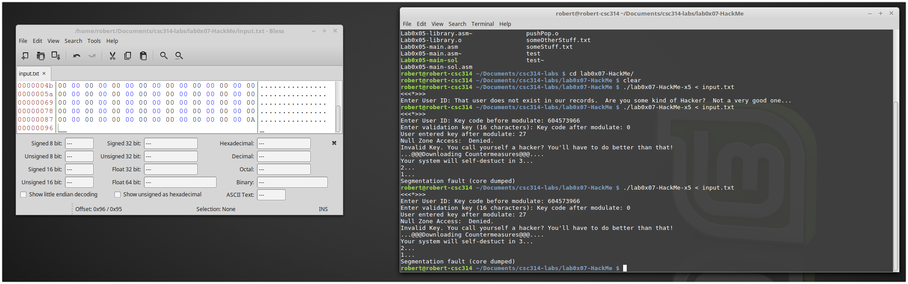

I’m a little frustrated at this point and just trying everything. I guess I didn’t learn the other times that this wasn’t going to work.

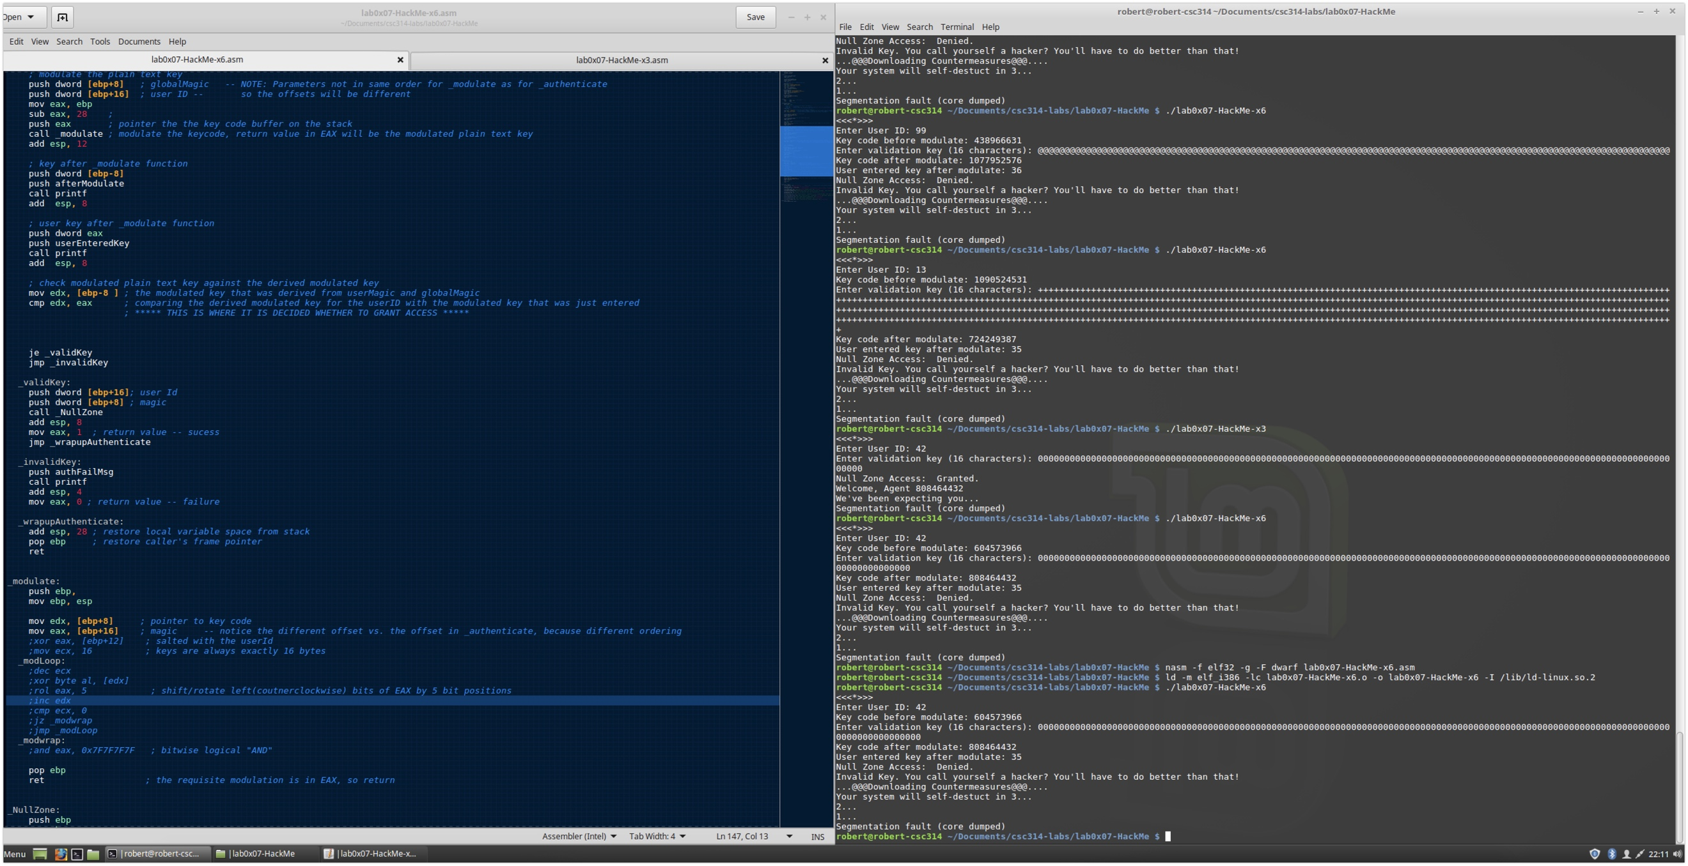

More access denied and more frustration.

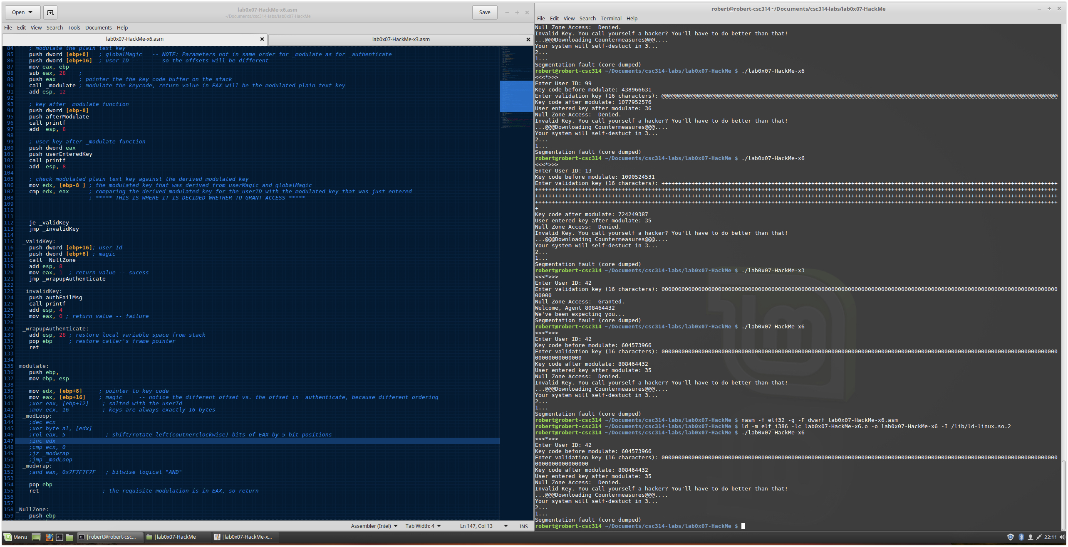

Now I’m testing if I can use something different in the userid

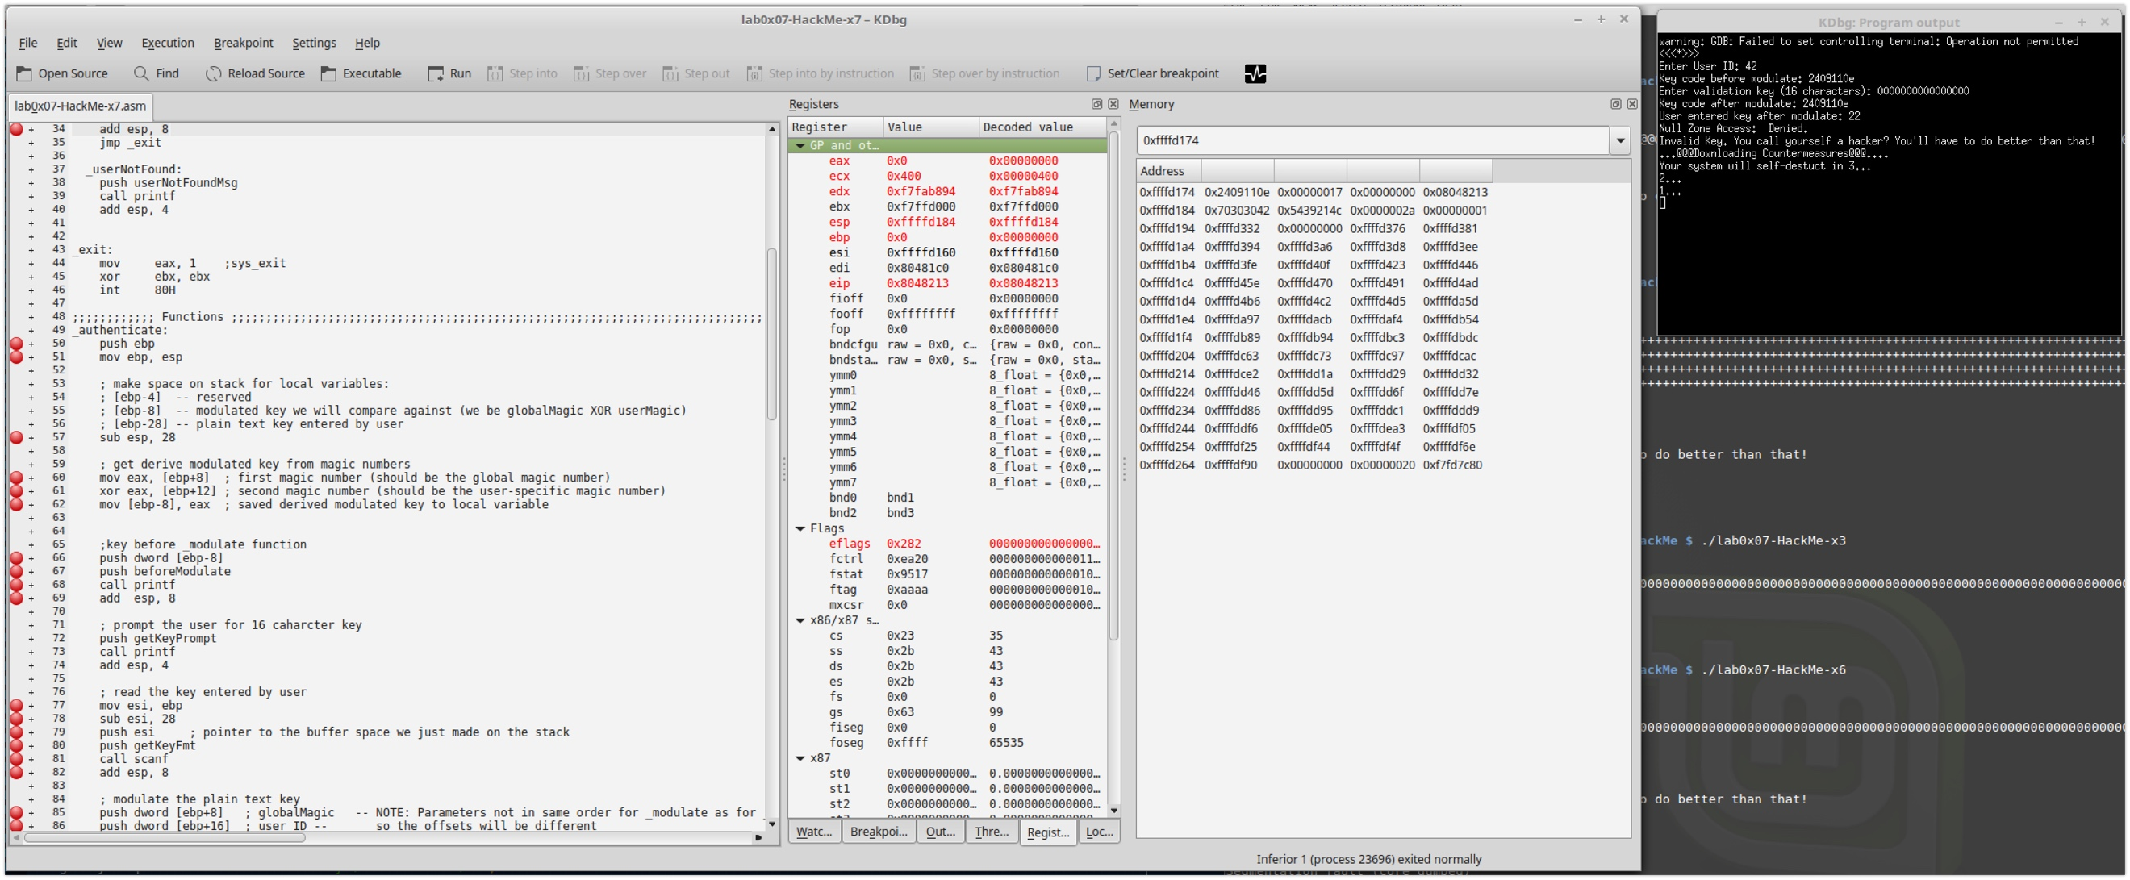

The next few screens are more focused testing with the memory. This is my last version x8 the previous versions I used to print out what the key was, but it was all in decimal. I modified the code to show hexadecimal with %x and after that is when I was able to really understand better what I needed to do.

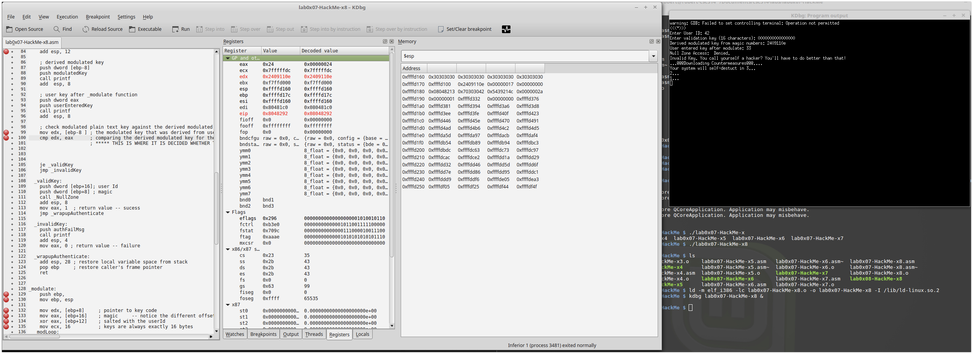

This shows what I learned from the screenshots above where different sections of the validation key entered is overrunning different parts of memory. I used 0s, 1s, 2s, and 3s to help me pinpoint what portion of the validation key was getting used. I did it this way, because I realized that I was having some difficulty counting bytes and figuring out where the code was grabbing the entered validation keys.

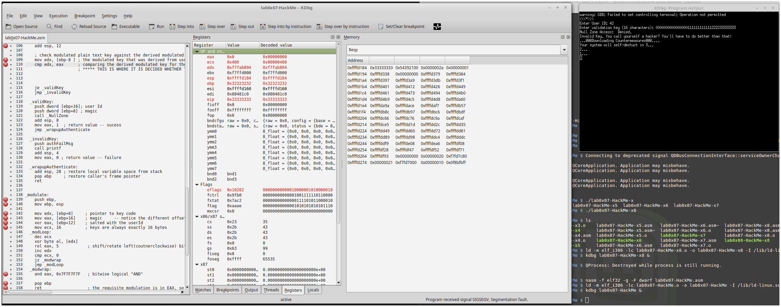

Testing the input file again, but paying more attention to the memory than I was previously

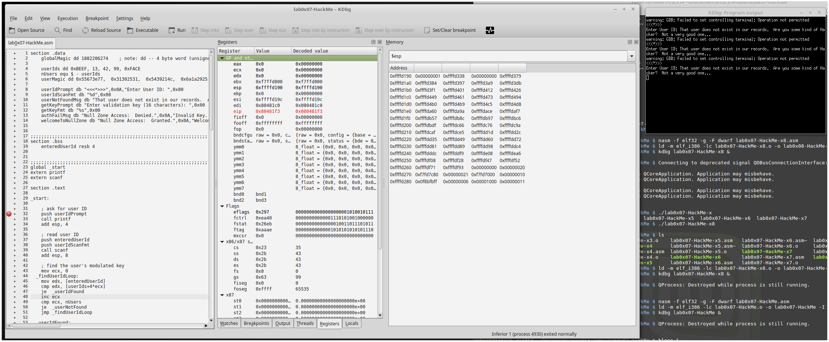

Fruits of my labor is paying off. I noticed that my 2s were being used as the key so I entered in what I wanted the key to be since I knew what the modulate function would turn my 3s into. I didn’t think about little endian when I was entering it into the bless editor.

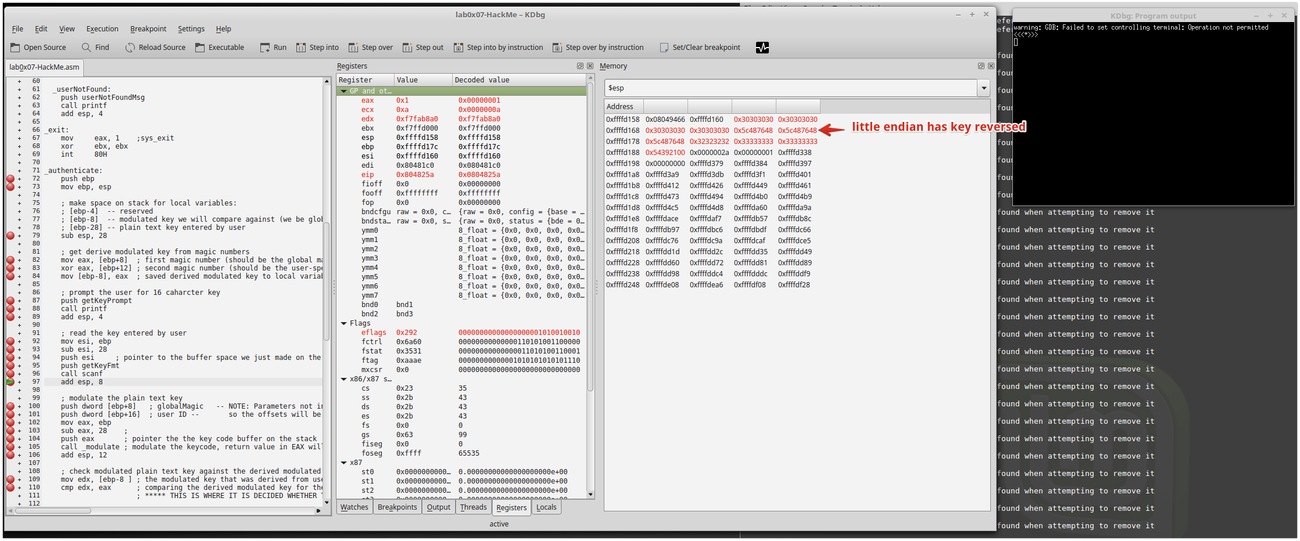

Now I got the key right within the bless editor. I’m showing with arrows how it is all going where I planned for it to go. I get the arrows out when I get excited, lol.

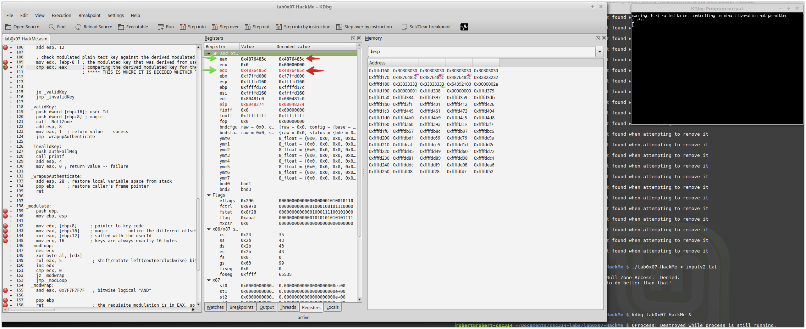

HUZZAH!!!! I went with userid 42, because Hitchhikers Guide is my favorite book and movie.

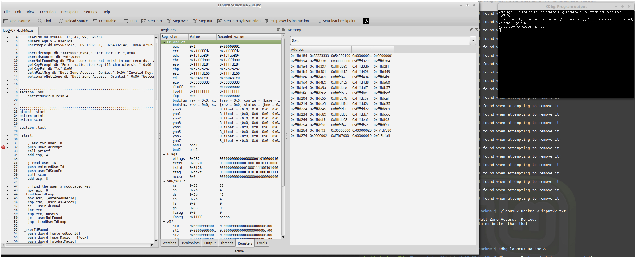

What a great experience this was working through lab0x07-HackMe it was very challenging for me, but so rewarding when I finally finished it!

